10 January 202X

Sales and Marketing | Financial | Operations
Premium customers won 23  Premium customers lost 1  Net Prem. Revenue Gain (monthly) $48K  Total customers won 156  Total customers lost 17  Net Prem. Revenue Gain 98$K | Sales Revenue $955K  Operating Profit $98K  Net Profit/ Loss $46K  Cash Collected $1.04M  Closing Balance $411K | CRM Implementation On-track  HQ Refurb Off-track  Systems Merge project On-track  New HR Policy On-track

Key decisions/discussions
List the main topics you want the board to consider in the meeting and the action needed.

 | Action
Topic #1 | Discussion
Topic #2 | Decision
Topic #2 | Noting

Top of mind
Areas of focus or concern for the CEO. What’s keeping you up at night or most exercising your mind.

Big wins/learnings
List a few big wins or key learnings achieved this quarter.
I.e. a major new channel partnership

CEO Summary and Metrics
Add a few sentences to summarise the position and direct attention of the board to what you see as most important.

[Name] of next level of key metrics
(Insert your own metrics graphs)

Revenue and Customer Overview 202X
Add commentary before the dashboard graphics, so that the board understands the context and what the data is saying.

(Graphs provided by www.datapine.com)

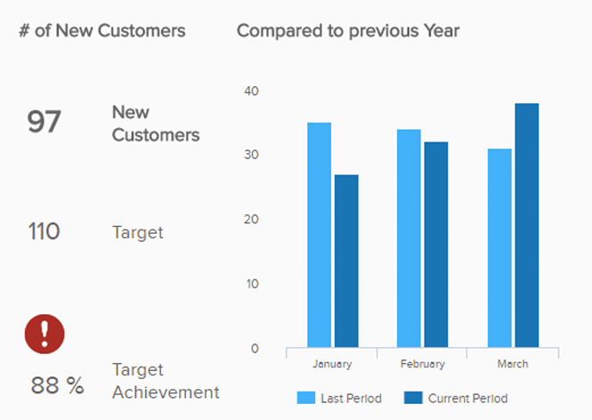
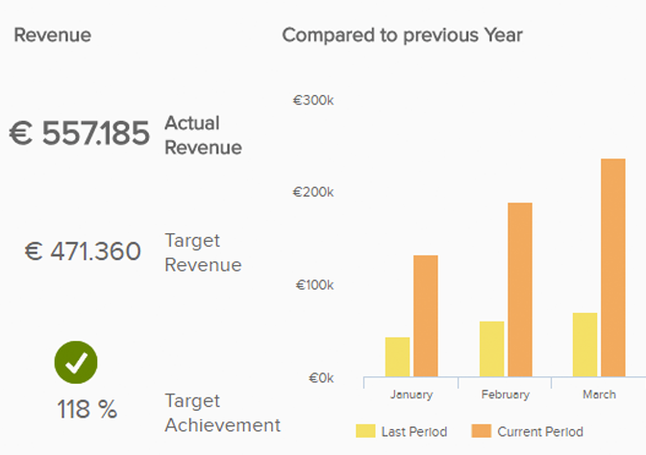

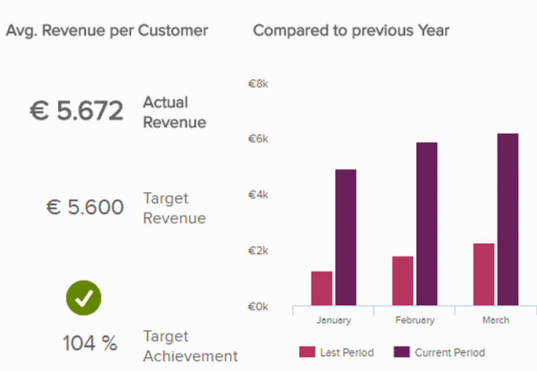
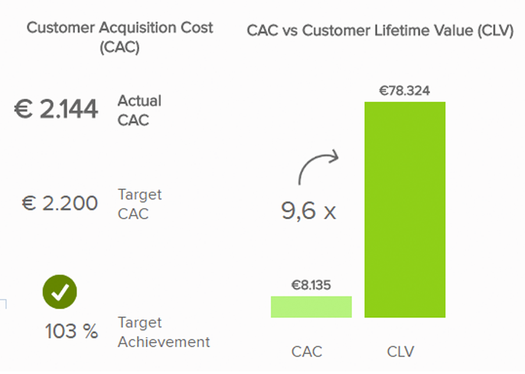

ADDITIONAL COMMENTS

Add commentary as required

